TICKET BOOKING SYSTEM

Tasks 1: Database Design:

1. Create the database named "TicketBookingSystem"

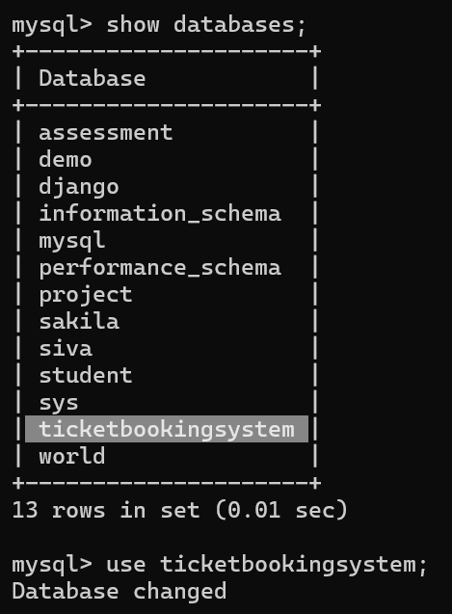

1. Write SQL scripts to create the mentioned tables with appropriate data types, constraints, and relationships.

* Venu
* Event
* Customer
* Booking

Venu Table:

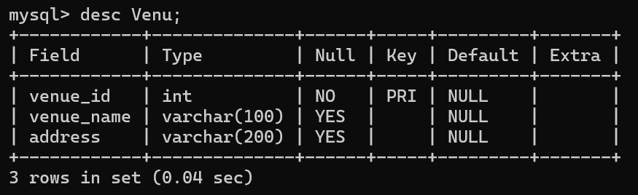

Event Table:

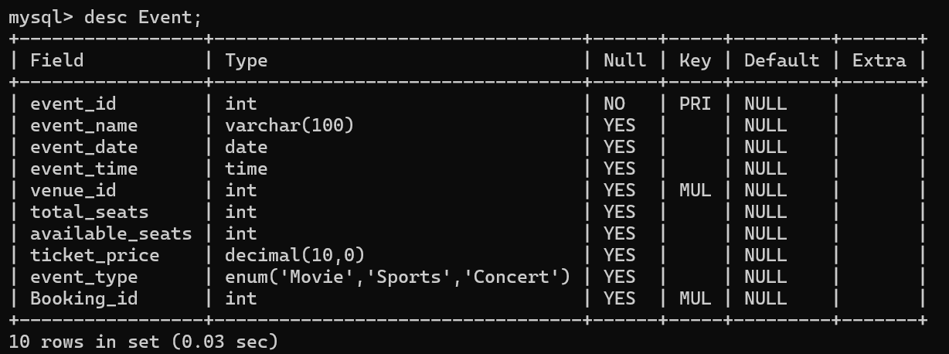

Customers Table:

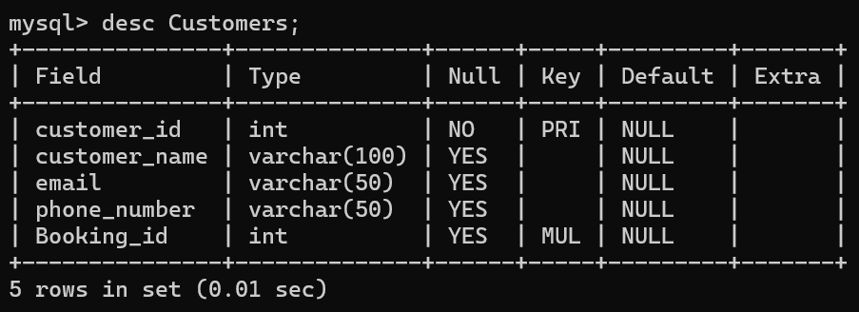

Booking Table:

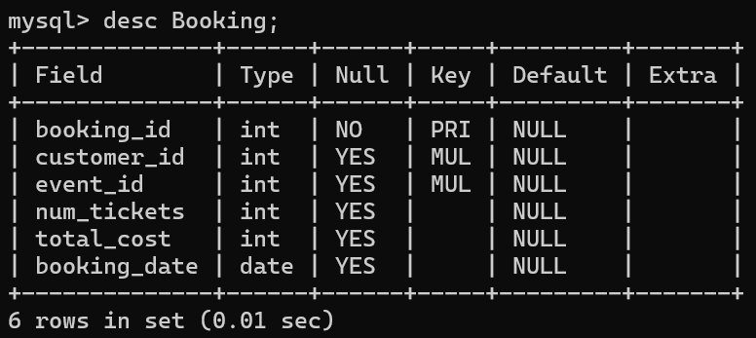

1. Create an ERD (Entity Relationship Diagram) for the database.

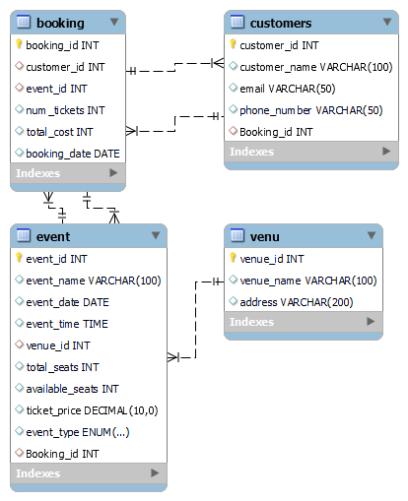

1. Create appropriate Primary Key and Foreign Key constraints for referential integrity.

Event booking_id:

mysql> ALTER TABLE Event

-> ADD Booking_id INT;

Query OK, 0 rows affected (0.04 sec)

Records: 0 Duplicates: 0 Warnings: 0

mysql> ALTER TABLE Event

-> ADD CONSTRAINT fk_Booking FOREIGN KEY (booking_id) REFERENCES Booking(booking_id);

Query OK, 0 rows affected (0.21 sec)

Records: 0 Duplicates: 0 Warnings: 0

Customers Booking_id:

mysql> ALTER TABLE Customers

-> ADD Booking_id INT;

Query OK, 0 rows affected (0.05 sec)

Records: 0 Duplicates: 0 Warnings: 0

mysql> ALTER TABLE Customers

-> ADD CONSTRAINT fk_Customers_Booking FOREIGN KEY (booking_id) REFERENCES Booking(booking_id);

Query OK, 0 rows affected (0.15 sec)

Records: 0 Duplicates: 0 Warnings: 0